Scholarship Finder Multi-Agent System: Capstone Project Writeup
-Problem Statement-
Students often struggle to find suitable scholarships due to scattered information, inconsistent eligibility criteria, and the absence of a centralized filtering system. Preparing essential documents like SOPs and CVs is also time-consuming and requires strong writing skills.
Additionally, there is no unified workflow that can:
· understand user profiles,
· match relevant scholarships,
· generate professional documents,
· refine drafts iteratively,
· and ensure final-quality validation.
This leads to manual effort, confusion, and missed opportunities.
-Solution Statement-
We built a multi-agent orchestrated scholarship assistant using Google ADK. The system combines tool-based control, memory, sub-agent collaboration, and iterative refinement to deliver a fully automated workflow:
· Personalized scholarship matching
· SOP/CV generation
· AI-driven refinement (LoopAgent)
· Optional human-in-the-loop approval
· User profile storage for future sessions

This creates a reliable, end-to-end assistant that reduces time, improves accuracy, and ensures polished document quality.
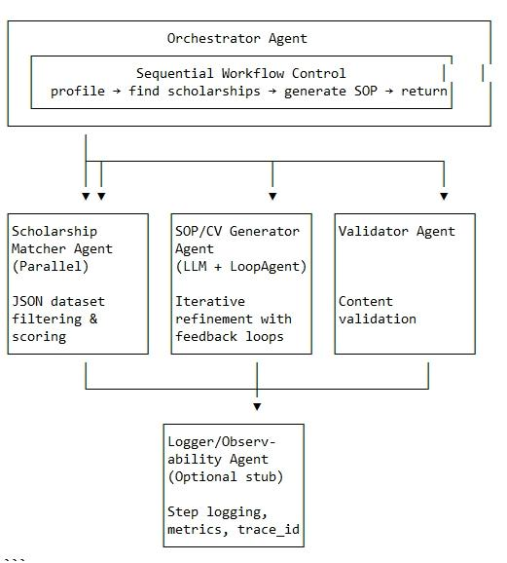
-Architecture-
Our multi-agent system follows a hierarchical architecture with an Orchestrator Agent at the root level coordinating various specialized sub-agents.The SOP and CV pipelines use LoopAgents to iteratively refine drafts until quality validation passes.The orchestrator coordinates all sub-agents through tool calls, ensuring deterministic and explainable behavior.
If the scholarship finder returns an empty result, the system falls back to the ADK-powered google_search tool.
Note:
Note : This diagram visualizes our orchestrated multi-agent pipeline including parallel filtering, iterative refinement, and validation
The architecture supports both sequential and parallel execution patterns, allowing for efficient processing while maintaining the flexibility to adapt to different user requirements.
-Agents and Their Functions-
1. Orchestrator Agent
The root agent that controls the overall workflow, coordinating all other agents in a sequential manner:
- Initiates the scholarship search process
- Manages the transition between different phases
- Handles session management and context preservation
- Implements memory and context compaction for efficient processing
2. Scholarship Matcher Agent
Operates in parallel mode to efficiently find relevant scholarships:
- Filters scholarships from JSON dataset based on user profile
- Scores scholarships based on eligibility, fit, and funding level
- Falls back to web search if local dataset doesn't yield sufficient matches
- Returns top-k scholarships with relevance scores
- If internal matching returns zero results, the agent triggers the external google_search tool as a fallback to ensure broader coverage.
3. SOP/CV Generator Agent
Creates tailored application materials using LLM capabilities:
- Generates initial drafts based on user profile and scholarship requirements
- Incorporates LoopAgent for iterative refinement
- Supports human-in-the-loop feedback through pause/resume mechanisms
- Maintains context across multiple iterations
4. Validator Agent
Ensures the quality and completeness of generated documents:
- Validates SOPs and CVs against specific criteria (word count, formatting, etc.)
- Checks for inclusion of required elements (scholarship name, etc.)
- Provides feedback for refinement
- Works with LoopAgent to implement validation feedback loops
5. Logger/Observability Agent
Monitors and records system operations:
- Maintains trace IDs for tracking workflows
- Logs agent steps and decisions
- Collects metrics for system evaluation
- Provides debugging information
-Essential Tools and Utilities-
1. Scholarship Finder Tool
- Reads and processes JSON scholarship datasets
- Implements filtering and scoring algorithms
- Handles dataset path resolution to eliminate manual path specification
- Integrates with web search for extended scholarship discovery
2. LLM Tool
- Interfaces with OpenAI/Gemini APIs for content generation
- Processes user profiles and scholarship information
- Generates contextually appropriate SOPs and CVs
- Handles prompt engineering for optimal outputs
3. Validation Tools
- Implements validation rules for different document types
- Checks formatting, content completeness, and relevance
- Provides structured feedback for document improvement
- Supports customizable validation criteria
4. Checkpoint/Resume Tool
- Saves intermediate states during document generation
- Enables pause/resume functionality for human-in-the-loop interactions
- Maintains iteration counts and version history
- Supports recovery from interruptions
5. Observability Tools
- Implements logging for all agent interactions
- Tracks performance metrics and success rates
- Maintains traceability across the entire workflow
- Provides visualization of agent operations
“A human-in-the-loop reviewer tool is also integrated to allow optional manual approval after the AI refinement stage”
6. Session Management Components
- Preserves user context across multiple interactions
- Implements memory management for efficient processing
- Supports context compaction to handle long conversations
- Maintains user preferences and history
-Conclusion-
Our Scholarship Finder Multi-Agent System represents a comprehensive solution to the challenges students face in discovering and applying for scholarships. By combining specialized agents with targeted tools, we've created a workflow that not only identifies relevant opportunities but also assists in crafting tailored application materials. The system's architecture balances automation with user control through human-in-the-loop mechanisms, ensuring that generated content meets both technical requirements and personal preferences.
The implementation of session management, memory, and context compaction across the system addresses the technical limitations of previous approaches, eliminating the need for manual dataset path specification and enabling more natural interactions. The observability components provide valuable insights into system performance, facilitating continuous improvement and reliability.
This multi-agent approach demonstrates the potential of AI systems to streamline complex, multi-stage processes while maintaining flexibility and user agency. As the system evolves, it has the potential to significantly reduce the barriers students face in securing scholarship funding, making higher education more accessible to deserving candidates. The design aligns with Google ADK’s best practices: orchestrated control flow, persistent memory, function tools, and multi-agent collaboration

